Welcome to ATLAS!
ATLAS Url: atlas.nbpts.org
ATLAS is s a library of authentic video cases showing National Board Certified Teachers at work in the classroom.
Review these definitions before you get started:
- Organization - the name of your school, college or university.
- Video case or case - ATLAS video cases include a video, the teacher’s written commentary and instructional materials. View this video to learn about the case page: https://help.atlas.nbpts.org/support/solutions/articles/42000065026-video-exploring-an-atlas-case-page
- ATLAS Organization Administrator – someone from your school that is managing users in your ATLAS organization. The National Board staff does not add, deactivate or remove users. Your ATLAS Organization Administrator’s name is in your ATLAS welcome email.
- Account – once you have a username, created a password and accepted the ATLAS terms of service, you have activated your account.
Let’s Get Started!
1. Create your account
You will receive a welcome email from atlassupport once you are added to ATLAS by the ATLAS Organization Administrator at your school. Your instructor will also be able to add you to ATLAS when they create a group.
Check your spam or junk folder if you do not see it. If you didn’t receive it, you can complete your ATLAS account setup by going to the ATLAS login page at atlas.nbpts.org, clicking on the Forgot your password? link and entering in the email that your ATLAS Organization Administrator used to add you to ATLAS.
Note: Typically, your school email is the email that was used to add you to ATLAS. It’s important to use the correct email to complete your account setup. If you enter the incorrect email, you will receive an error message.

2. Access video cases
There are 4 ways to access ATLAS video cases:
a. Cases Page: Click on the filters on the left to find video cases by Subject, Topic, Grade and Frameworks.
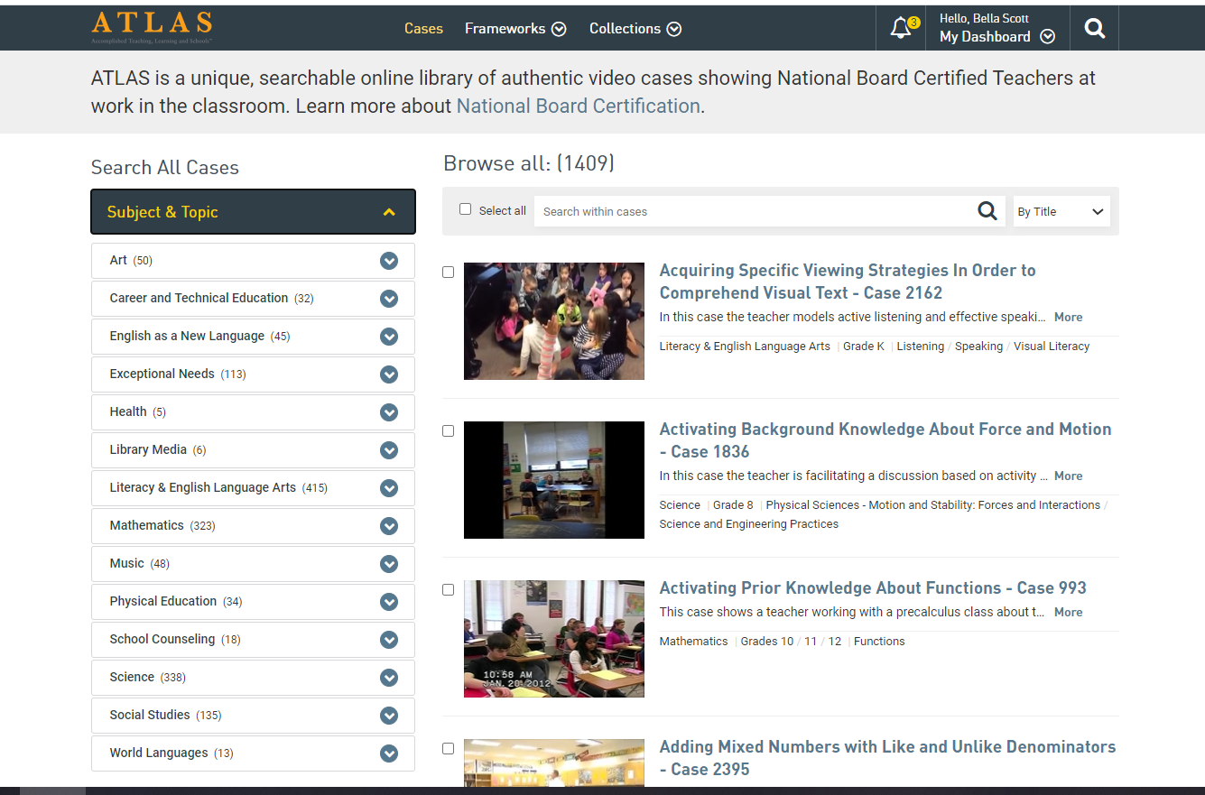
b. Groups: Your Instructor can create a group and add students and video cases to the group. To access your group, open your Dashboard and select your group/class name. If you are a member of more than 3 groups, click on the Create and Manage Groups link to access all of your groups.
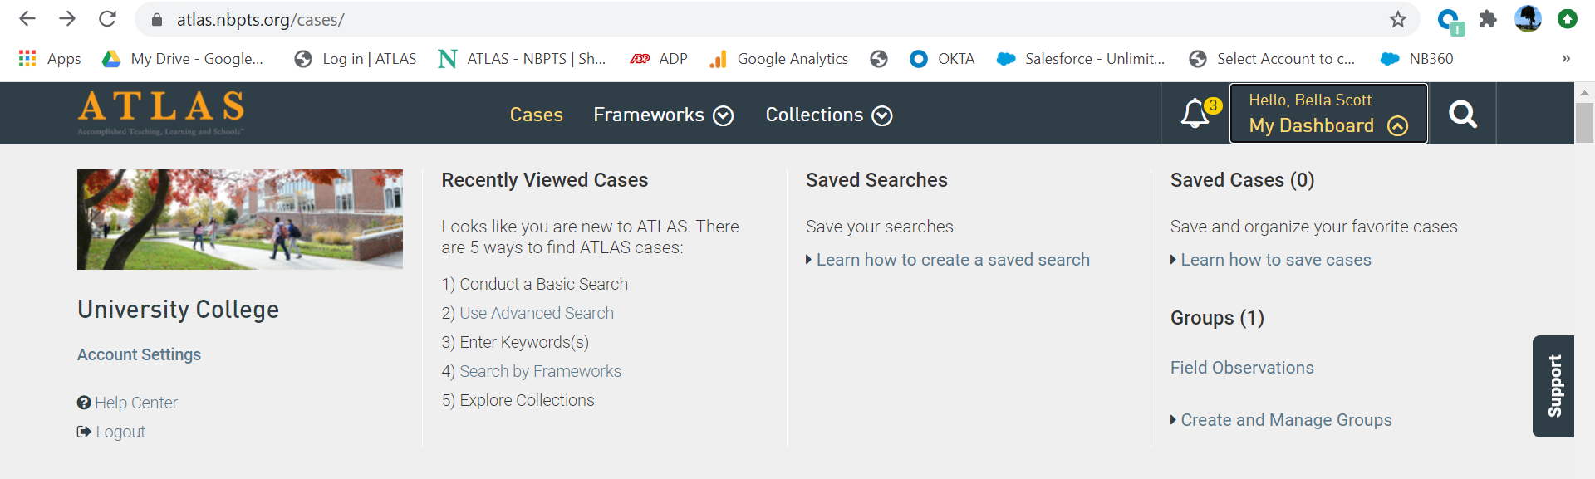
c. Keyword search a topic, subject or strategy of your choosing. You may also enter the case number or title provided by your faculty. Every ATLAS video case has a case number. For video cases with common case numbers (e.g., 1) enter “Case 1” (with the quotation marks) into the keyword search box. If you do not do this every case that has the #1 in the title, description, grade, etc. will appear in your search results. You may enter the case number only for Cases with unique numbers (e.g. 1836). View this video to learn more about conducting a keyword search: https://help.atlas.nbpts.org/support/solutions/articles/42000061697-video-conducting-a-keyword-search-on-atlas.

d. Explore the Advanced Search or Framework pages to learn other ways to find a case (e.g., by strategy, School Setting, Student Characteristics). View this video for more information on how to conduct an Advanced Search: https://help.atlas.nbpts.org/support/solutions/articles/42000061696-video-conducting-an-advanced-search-on-atlas
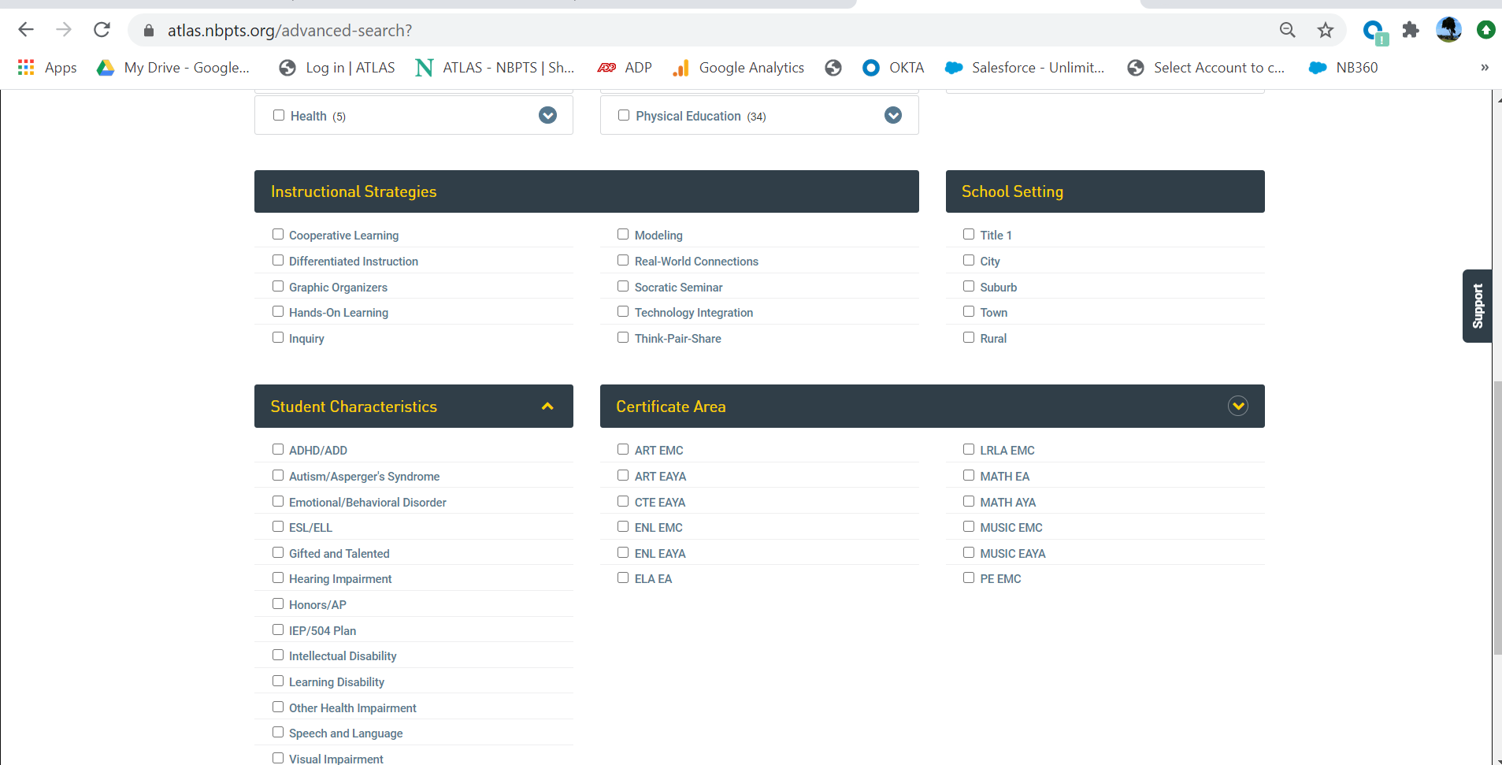
Login to ATLAS to read more help articles on the following topics:
Saving a case:
https://help.atlas.nbpts.org/support/solutions/articles/42000049425-saving-a-case
Adding a note to the commentary:
https://help.atlas.nbpts.org/support/solutions/articles/42000049895-adding-a-note-to-the-commentary
Adding a note to the video:
https://help.atlas.nbpts.org/support/solutions/articles/42000049884-adding-a-note-to-the-video
Adding a note to the Instructional Materials:
https://help.atlas.nbpts.org/support/solutions/articles/42000049898-adding-a-note-to-the-instructional-materials
Troubleshooting
- If you receive a message that your account is not associated with an organization, make sure you are using the correct email address. You may need to clear your cache.
- Some users will have been added to ATLAS and later deactivated by their ATLAS Organization Administrator. If this happens, you will receive an account deactivated message when you attempt to login. Please contact your faculty or the ATLAS Organization Administrator and ask them to add you to ATLAS. Email us at atlassupport if you need their contact information.
- If you know who your ATLAS Organization Administrator is, please email them with your login problems before reaching out to the National Board. 95% of the time, login issues are caused by users entering an incorrect email address.

